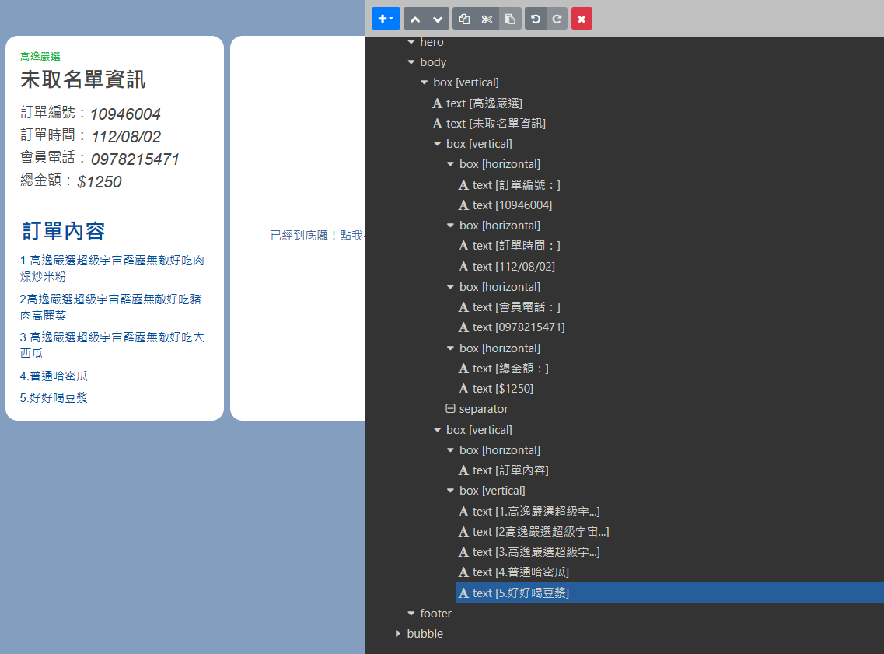

{

"type": "carousel",

"contents": [

{

"type": "bubble",

"body": {

"type": "box",

"layout": "vertical",

"spacing": "none",

"contents": [

{

"type": "text",

"text": "高逸嚴選",

"wrap": true,

"weight": "bold",

"size": "sm",

"color": "#1DB446",

"align": "start"

},

{

"type": "text",

"text": "未取名單資訊",

"margin": "xs",

"size": "xxl",

"weight": "bold"

},

{

"type": "box",

"layout": "vertical",

"contents": [

{

"type": "box",

"layout": "horizontal",

"contents": [

{

"type": "text",

"text": "訂單編號：",

"size": "lg",

"margin": "none",

"flex": 0

},

{

"type": "text",

"text": "10946004",

"margin": "none",

"size": "xl",

"offsetStart": "none",

"offsetEnd": "none",

"offsetBottom": "none",

"offsetTop": "none",

"style": "italic"

}

]

},

{

"type": "box",

"layout": "horizontal",

"contents": [

{

"type": "text",

"text": "訂單時間：",

"size": "lg",

"margin": "none",

"flex": 0

},

{

"type": "text",

"text": "112/08/02",

"size": "xl",

"margin": "xs",

"style": "italic"

}

]

},

{

"type": "box",

"layout": "horizontal",

"contents": [

{

"type": "text",

"text": "會員電話：",

"size": "lg",

"flex": 0

},

{

"type": "text",

"text": "0978215471",

"size": "xl",

"margin": "xs",

"style": "italic"

}

]

},

{

"type": "box",

"layout": "horizontal",

"contents": [

{

"type": "text",

"text": "總金額：",

"size": "lg",

"margin": "none",

"flex": 0

},

{

"type": "text",

"text": "$1250",

"size": "xl",

"margin": "xs",

"style": "italic"

}

]

},

{

"type": "separator",

"margin": "xxl"

}

],

"margin": "lg"

},

{

"type": "box",

"layout": "vertical",

"contents": [

{

"type": "box",

"layout": "horizontal",

"contents": [

{

"type": "text",

"text": "訂單內容",

"margin": "xs",

"size": "xxl",

"weight": "bold",

"color": "#004D99"

}

],

"margin": "lg"

},

{

"type": "box",

"layout": "vertical",

"contents": [

{

"type": "text",

"text": "1.高逸嚴選超級宇宙霹靂無敵好吃肉燥炒米粉",

"wrap": true,

"margin": "md",

"size": "md",

"color": "#004D99"

},

{

"type": "text",

"text": "2高逸嚴選超級宇宙霹靂無敵好吃豬肉高麗菜",

"wrap": true,

"margin": "md",

"size": "md",

"color": "#004D99"

},

{

"type": "text",

"text": "3.高逸嚴選超級宇宙霹靂無敵好吃大西瓜",

"margin": "md",

"size": "md",

"wrap": true,

"color": "#004D99"

},

{

"type": "text",

"text": "4.普通哈密瓜",

"margin": "md",

"size": "md",

"wrap": true,

"color": "#004D99"

},

{

"type": "text",

"text": "5.好好喝豆漿",

"margin": "md",

"size": "md",

"wrap": true,

"color": "#004D99"

}

],

"margin": "none"

}

]

}

],

"margin": "xl"

}

},

{

"type": "bubble",

"body": {

"type": "box",

"layout": "vertical",

"spacing": "none",

"contents": [

{

"type": "button",

"flex": 1,

"gravity": "center",

"action": {

"type": "message",

"label": "已經到底囉！點我按下一頁",

"text": "【未取名單 下一頁】"

},

"margin": "xxl"

}

]

}

}

]

}